Christmas Tree 1 (Illustrator) and 2 (Photoshop)

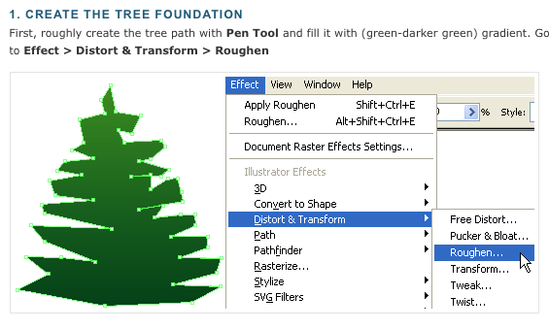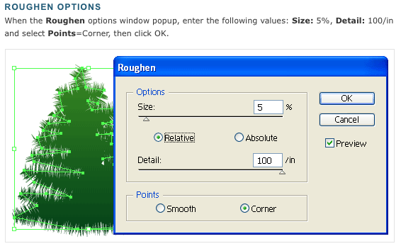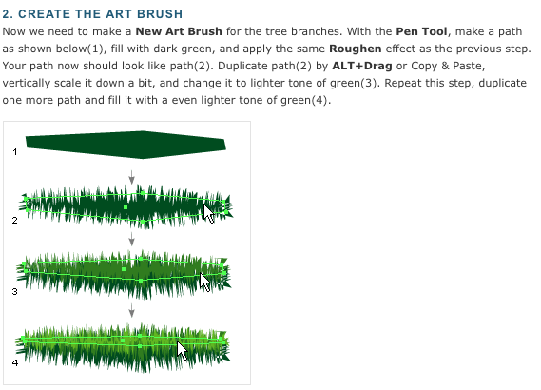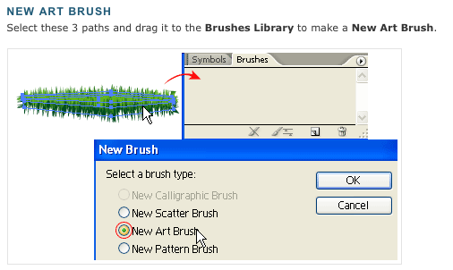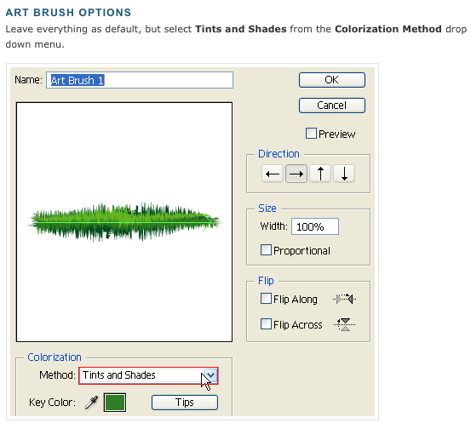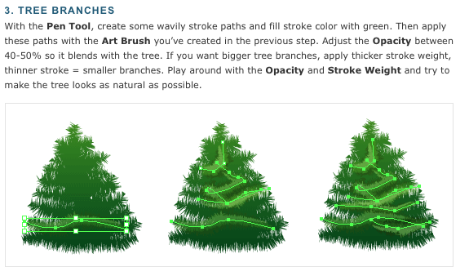

Making balls

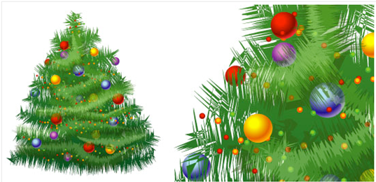
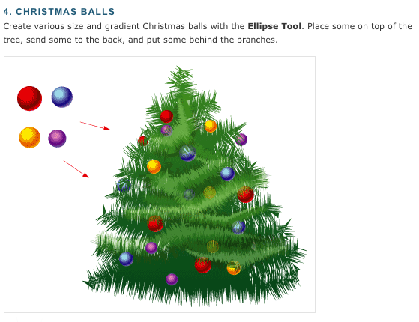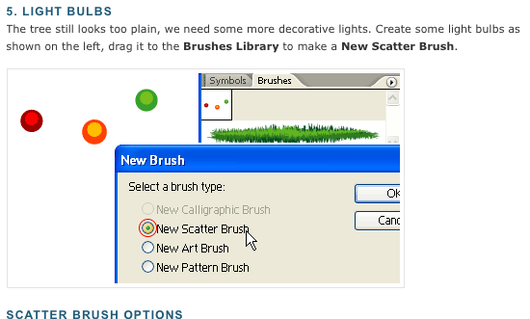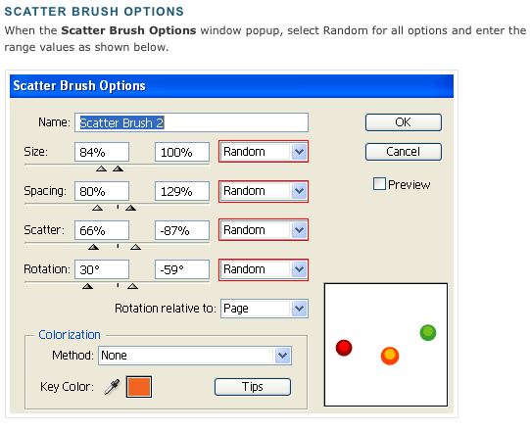

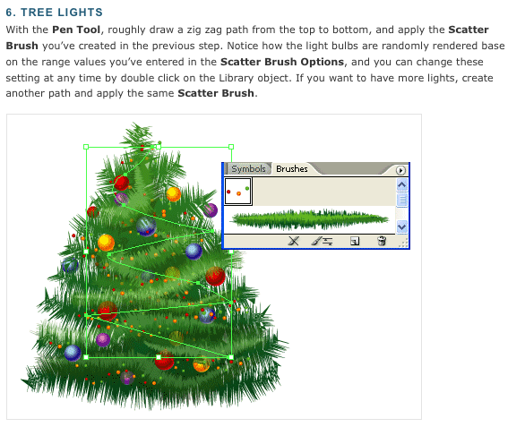

Now you can make some items to hang on your tree (do NOT copy and paste these) make your own!

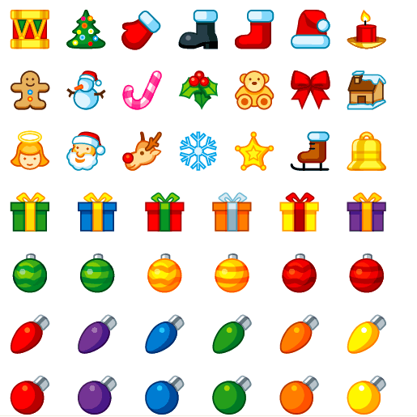

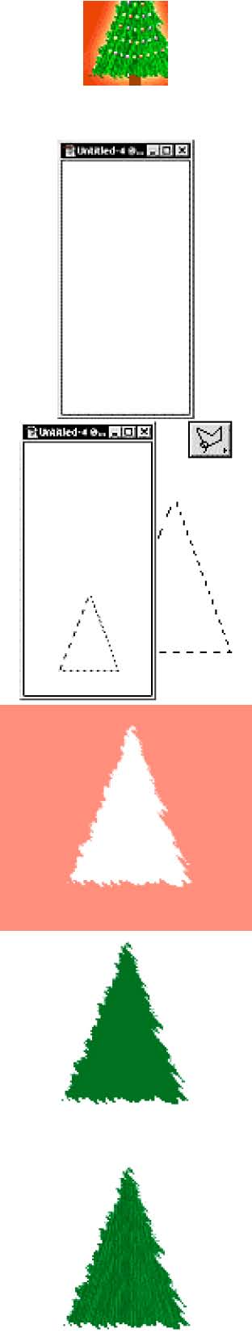
Christmas Tree Photoshop
Make a new image. 150 pixels wide by 300 pixels high. The height may seem a little strange, but because of the way the Extrude filter works, we'll have to do it this way. We will be working on the bottom half of this image.
Christmas Tree Photoshop
Make a new Layer. Select the Polygon Lasso Tool. Make a Christmas tree like shape in the bottom half of the image.
Press the Quick Mask button. It's on the Tool bar towards the bottom J. Go to Filter>Brush Strokes>Sprayed Strokes. Enter 19, 6 and choose Left Diagonal.
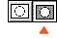
Switch Back to Standard Mode. Use the Paint Bucket and fill the selection in with green. I used Hex # 007624. Now Select>Deselect.
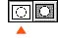
Ok we now have a cool little tree. You can stop here, or move on to make the tree texture. Go to Filter>Stylize>Extrude. Select Pyramids, Size: 2. Depth:
40. Random. Click OK.
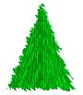
Use the Contrast to bring out the texture. Image>Adjust>Brightness/Contrast. Enter: -10 and +50.


